# JavaScript Homework #4 – Simple Algorithm

***Crown and Anchor* game**

There are six squares with symbols for “Crown,” “Anchor,” “Heart,” “Club,” “Spade,” and “Diamond.”

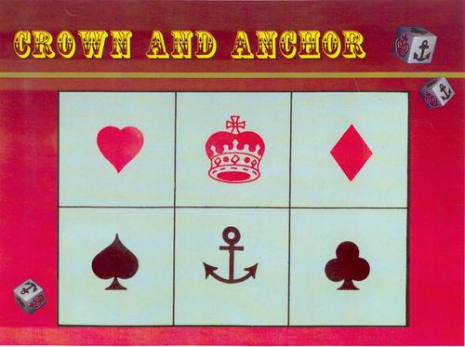

A player places any number of coins on any combination of the squares: these become the bets. Then he rolls three six-sided dice with faces that match the squares. For each die that matches a square that has a bet on it, the sailor wins that amount of money. The player loses the money where its square doesn’t have a matching die.

Write a program to play this game with 1) the given amount of coins (cents), and 2) the given number of rounds. The program ends when 1) the player runs out of money, or 2) it reaches the given number of rounds. In this case, the winning amount should be outputted.